**Date / Time Received**:Click or tap here to enter text. **Initial or Follow-up ALERT REPORT?** Click or tap here to enter text.

**Circumstance:** **Brief Description**:

Click or tap here to enter text.

**People Involved**:

**Internal**: Click or tap here to enter text.

**External**: Click or tap here to enter text.

**Crisis Risk Identification POTENTIAL (CIRCLE ELVALUATION): Guarded / Elevated / Severe**

**REACTION INDICATORS DESCRIPTION:**

**Anger:** Click or tap here to enter text.

**Blame:** Click or tap here to enter text.

**Concern**: Click or tap here to enter text.

**EXTENT INDICATORS Description:**

**Spread:** Click or tap here to enter text.

**Speed:** Click or tap here to enter text.

**Setting**: Click or tap here to enter text.

**Identify the blended CrisisRisk Level data point on the Matrix below**

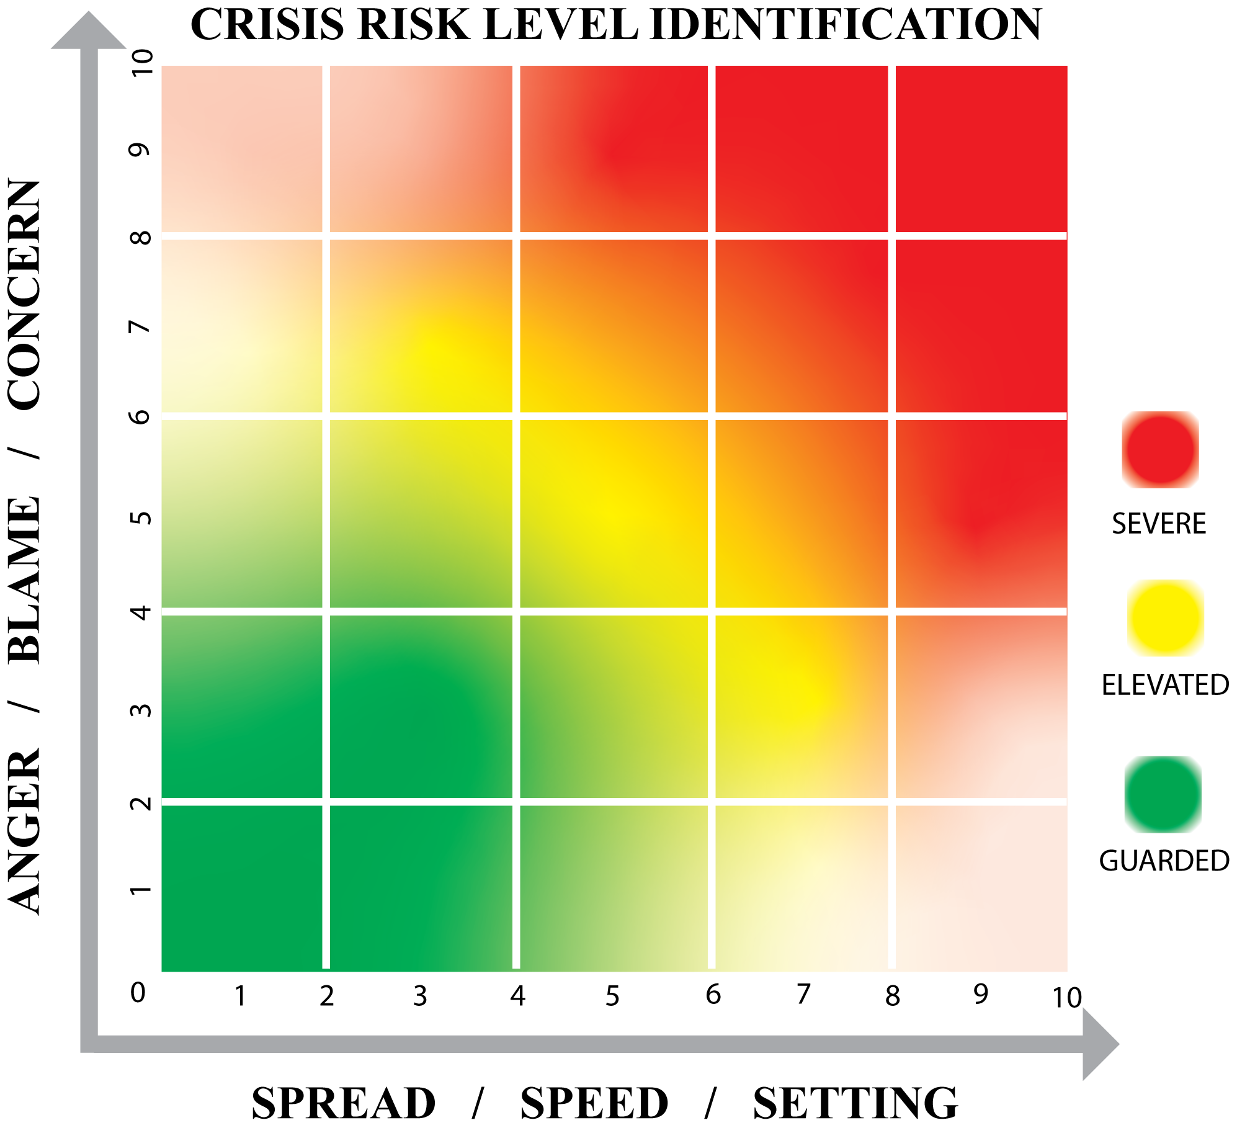

**INDICATE:**

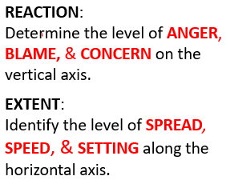

**NEXT Follow Up Expected When:**

Click or tap here to enter text.

**Additional Input**:

Click or tap here to enter text.